**Task 18 (output)**

1. FaceBook create new account.

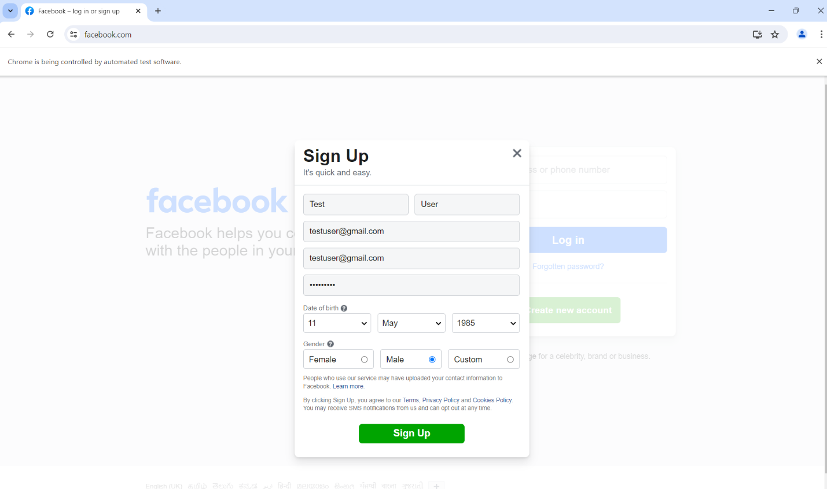

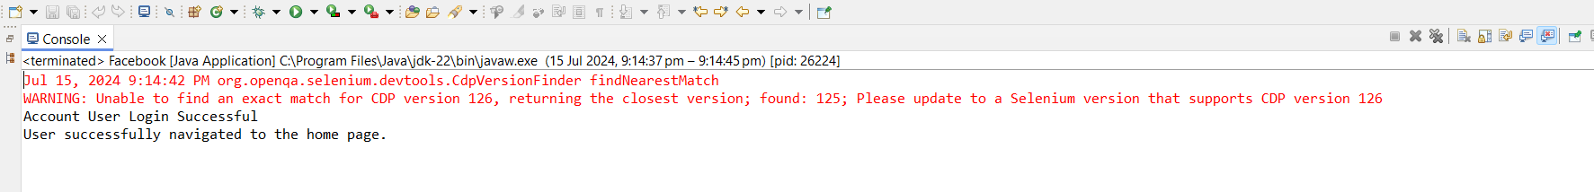

1. Drag and drop application

